**AL KHOZAMA INTERNATIONAL SCHOOL, DAMMAM, K.S.A**

**Affiliated to CBSE – New Delhi, Affiliation No. 57300019**

**WORKSHEET- 2**

**GRADE: 3– FIRST TERM EXAMINATION/EVALUATION I**

**SUBJECT: MATHEMATICS**

**Block 17**

1. 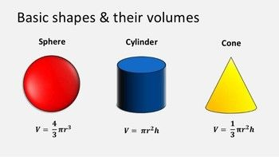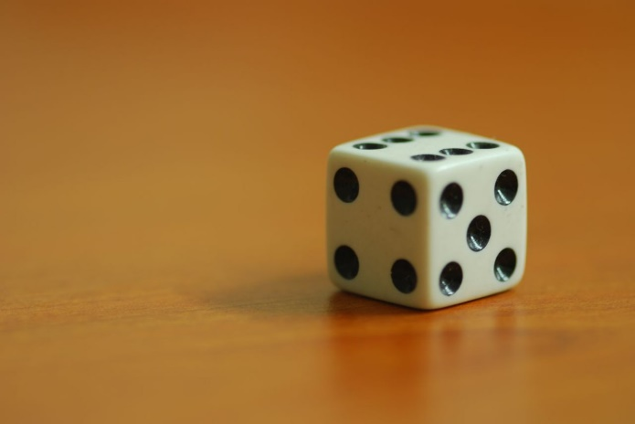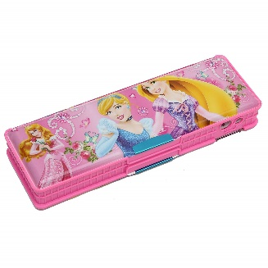 Identify the 3D shapes:



1. The sides of 3D shapes are made from 2D shapes.
2. A cube has ______ faces, ____ edges and _____ corners.
3. A cuboid has ______ faces, ____ edges and _____ corners.
4. A cone has ______ faces, ____ edges and _____ corners.
5. A cylinder has ______ faces, ____ edges and _____ corners.
6. A sphere has ______ faces, ____ edges and _____ corners.
7. Write the name of the 3D shapes
8. Football b. birthday cap c. lunch box
9. How is a cone different from a cylinder?
10. What is the common property between cube and prism?
11. Name 2 shapes that can be made using 12 straws.
12. 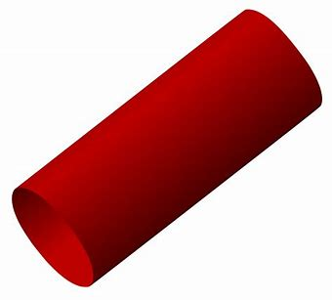

Can it roll or slide?