**AL KHOZAMA INTERNATIONAL SCHOOL,DAMMAM**

**Affiliated to CBSE – New Delhi, No:5730019**

Affiliated to CBSE – New Delhi, Affiliation No: 5730008

**WORKSHEET-II**

**FIRST TERM EXAMINATION (2021-22’)**

**Subject: Science**

Class: 6 **BLOCK NO:5, 6,7,10 &29**

**I.CHOOSE THE CORRECT ANSWER**

1. ________ is an example for magnetic substances?

a) Sand b) salt

c) Husk d) nail

1. The texture describes the __________________ of an object.

a) Color b) Feel

c) Smell d) Hardness

1. Which one is not related to filtration?

a) Residue b) filtrate

c) Funnel d) sedimentation

1. The part of the stem between the two nodes is called ___________

a) Internodes b) stalk

c) Node d) petiole.

**Answer the following questions**

1. Draw a Venn diagram for given diagram

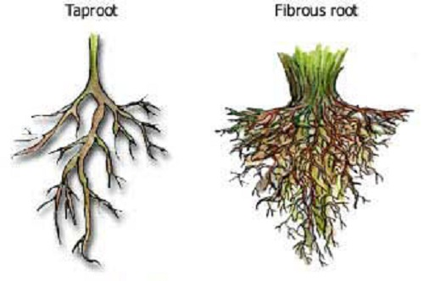

1. Why is it better to use rechargeable batteries instead of disposable batteries?
2. Why does an old banyan tree always have a very thick trunk?
3. Write any three application of centrifugation method. And label the parts of the given distillation process

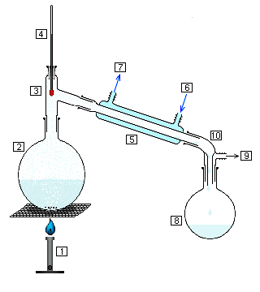

1. How is the type of roots related to the number of cotyledons of seeds in the plant?
2. Make a flow chart to show how a mixture of wheat flour, husk and small stones can be separated to get wheat flour for use.
3. How is garbage segregated before its disposal? How is transported to the landfill site.

xxxxxxxxxxxxxxxxxxxxxxxxxxxxxxxxxxxxxxxxxxxxxxxxxxxxxxxxxxxxxxxxxxxxxXX