**Al KHOZAMA INTERNATIONAL SCHOOL, DAMMAM,K.S.A**



Affiliated to CBSE – New Delhi **WORK SHEET-1**

**GRADE: II**

**EVALUATION-1, 2019-20**

**SUBJECT: EVS**

**Block 2: Amazing animals Block 6: Types of plants**

**Block 7: Importance of plants Block 8: Parts of our body**

**____________________________________________________________________________________________**

**I.Fill in the blanks**

**1.** Animals that live with us are called _____________

2. _________________are the animals that are less in number and becoming lesser day by day.

3.Herbs are added to food to give ___________

4. Sparrows have _____________ shaped beaks.

5. We get_____________ from hen.

6. Example for bird which do not build their own nest ____________ .

7. The ____________ joins head to the torso.

8. ________________ is the part of our body between the chest and hip.

9. The chest and abdomen make the __________ of our body

**II. Label the picture given below**

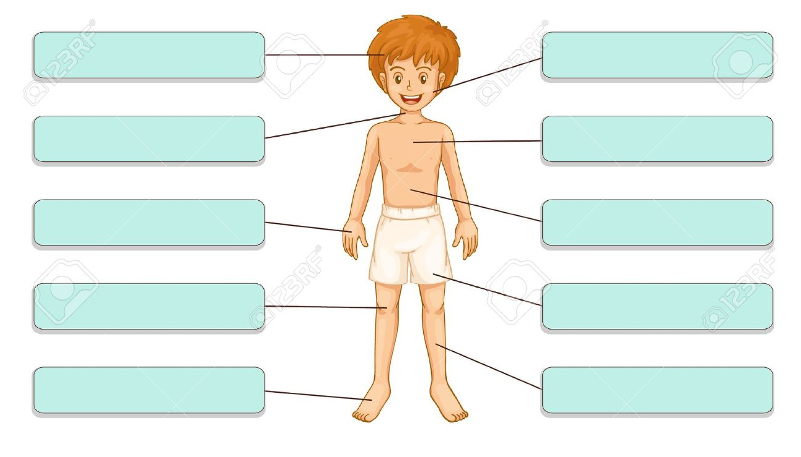

**III. Identify the picture and comment on it.**

1. 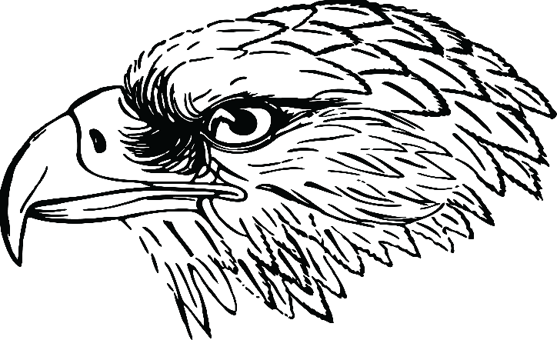

**2.** 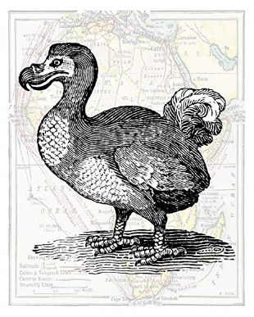

3.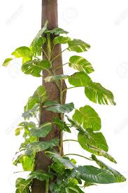

4. 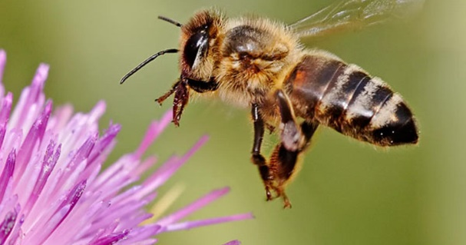

**IV. STATE TRUE OR FALSE**

1. Birds with strong and curved beaks eat seeds.
2. Cuckoo lays its egg in crow’s nest.
3. Climbers are the plants that grow by climbing on some support.
4. We should not give healthy food for pets.
5. We hear with our ears.

**V. MATCH THE FOLLOWING.**

1. Bougainvillea 1. Tree

2. Water melon 2. Shrub

3. Coriander 3. Climber

4. Rose 4. Herb

5. Mango 5. Creeper

**V.ANSWER THE FOLLOWING IN ONE SENTENCE.**

1.Write one feature of a shrub.

_______________________________________________________________________

2.Name 2 domestic animals.

3. Which part of our body makes a torso?

4. Mention the role of eye.

5. Which parts of your body do you use while bathing?

______________________________________________________________________________________________________________________________________

VI. ANSWER THE FOLLOWING IN 2 SENTENCES.

1. Why do people with physicals challenges need help?

______________________________________________________________________

2. Write names of 5 animals and why we should keep them at home?

_____________________________________________________________________________________________________________________________________________________________________________________________________________________________________________________________________________________________________________________________________________________________

1. What are the things a bird uses to build a nest? _____________________________________________________________________________________________________________________________________________________________________________________________________________________________________________________________________________________________________________________________________________________________

4. Brinjal plant is a herb. Give reason

______________________________________________________________________________________________________________________________________________________________________________________________________________________________________________________________________________________________________________________________________________________________

5. Why do creepers grow close to the ground?

____________________________________________________________________________________________________________________________________________________________________________________________________________________________________________________________________________________________________________________________________________________________

1. What is the difference between tree and a shrub?

____________________________________________________________________________________________________________________________________________________________________________________________________________________________________________________________________________

1. Why pet animals are kept at home?

_________________________________________________________________________________________________________________________________________________________________________________________________________

1. How do our sense organs help us to know about the world?

____________________________________________________________________________________________________________________________________________________________________________________________________________________________________________________________________________

1. Give 3 examples of each of the following.

|  |  |
| --- | --- |
| Herb |  |
| Shrub |  |
| Climber |  |
| Creeper |  |

*****************************************