**AL KHOZAMA INTERNATIONAL SCHOOL, DAMMAM, K.S.A**

**Affiliated to CBSE – New Delhi, Affiliation No. 57300019**

**WORKSHEET**

**GRADE: – FIRST TERM EXAMINATION /EVALUATION I**

**SUBJECT: English**

**SECTION A –READING COMPREHENSION**

1. Read the passage and answer the questions.

**Kindness Rewarded**

Ida was a kind-hearted girl, and one day when crossing a bridge, she saw two boys on the stream, trying to drown a little dog. So, she ran to the shore, and crying loudly, “Oh! How can you be so cruel to that poor little dog?” The boys looked at her in wonder, and one of them said,

“Father told us to drown it." The dog had reached the bank, crept toward Ida. “Poor little fellow," she said, patting his head, “Will you give him to me?"

“Yes,” said the boys, “You may have him and welcome." Ida thanked the boys and ran home.

"Oh! Mamma," she cried, "look at this dear little dog; two boys were trying to drown him and I asked them to give him to me. May I keep him, Mamma?" “My dear child," said Mrs. Mason, “I am very glad to hear that you saved the little dog from pain



1. What did Ida see when she was crossing the bridge?
2. Two boys playing with puppy
3. Two boys trying to drown puppy.
4. Why did the boys drown the little dog in the stream?
5. Because their father asked them to do
6. Because they were afraid of the puppy
7. Did the boys give the dog to Ida?
8. No
9. Yes
10. What is the title of the story?
11. Kindness Rewarded
12. Ida and the puppy

**SECTION B – GRAMMAR**

* + - 1. **Fill in the blanks.**

1. Aarav has a coat. ______coat is black.

* his
* it

1. I bake cake. _______ cake is good.

* their
* my

1. Juan and Patric are friends.__________friendship is nice.

* their
* our

1. Maria has a pen. She writes with ________pen.

* her
* my

1. Noel and I live together.______house is beautiful.

* Our
* Their

1. **Look at the picture and write the first two letters to start the word**.

1. _ _ oke



* sm
* st

1. _ _ ick



* sm
* st

1. _ _ irt



* sk
* sp

1. _ _ ort



* sp
* sk

**SECTION C – CREATIVE WRITING**

* + - 1. Look at the picture and describe it in three sentences.

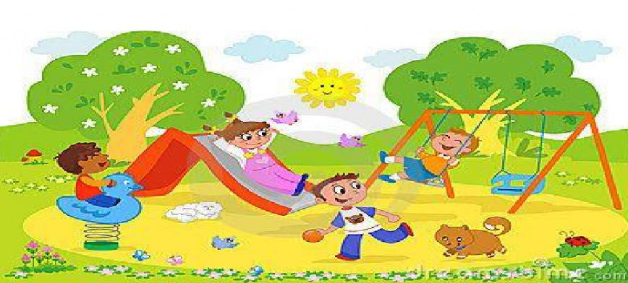

___________________________________________________________________________________________________________________________________________________________________________________________________________________________________________________________________________________________________________________________________________________________________________________________________________________________________________________________________________________________________________________________________________________________

* + - 1. Write questions for the following answers.

1. ___________________________________________________

Ans: I go to school by car.

1. ___________________________________________________

Ans: I live in Saudi Arabia.

c)______________________________________________________

Ans: He is my teacher.

**SECTION D – LITERATURE**

Answer the following questions.

1. Why was Ben sad?
2. What does Ben’s mother tell him?
3. What happens in the end of the story “Ben’s Christmas Wish”?