**AL KHOZAMA INTERNATIONAL SCHOOL,DAMMAM**

**Affiliated to CBSE – New Delhi, No:5730019**

Affiliated to CBSE – New Delhi, Affiliation No: 5730008

**WORKSHEET 2**

**( BLOCK 21 & 25)**

**Subject:SOCIAL SCIENCE**

Class: 6

1. **NAME THE GIVEN PICTURES.**
2. 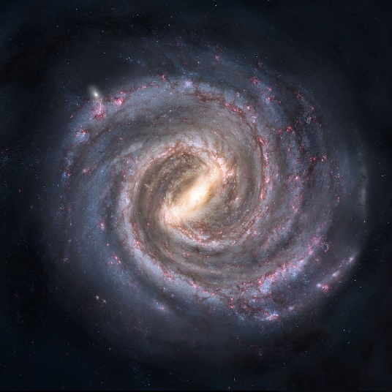 b. 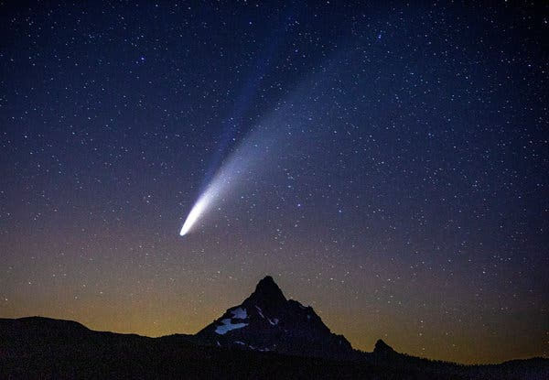

C**.** 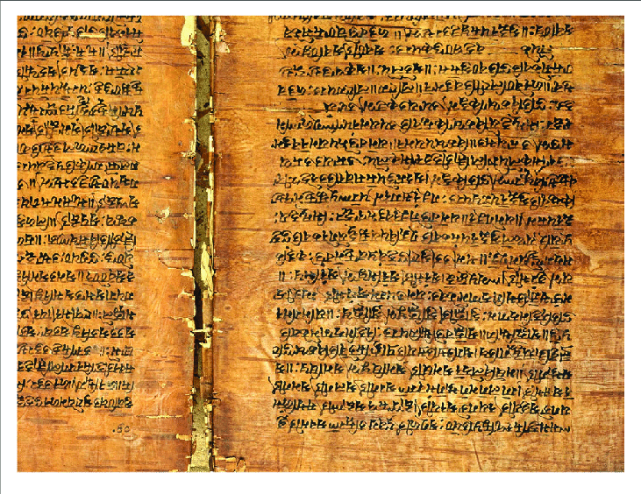d. 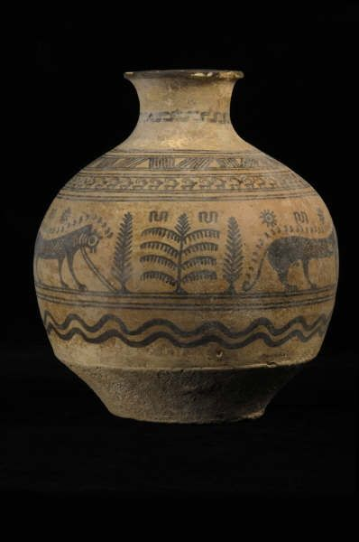

e. 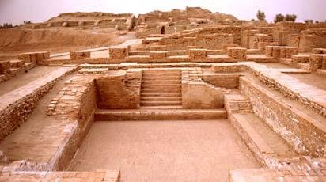

f. 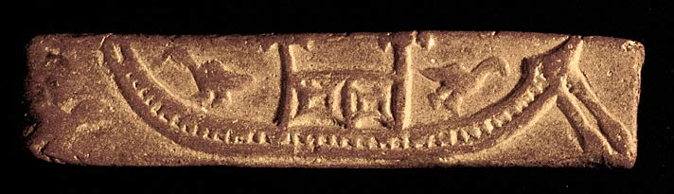

1. **FILL IN THE BLANKS**
2. Satellites reflect the light of the ______.
3. Venus is the only planet that rotates in the __________ direction.
4. Due to their size and composition, the outer planets are referred to as __________
5. ___________ is the largest continent in the world.
6. The _______ is the crust of the earth made of rock and soil.
7. The level of ________ remains the same throughout the world.
8. Over 97% of water was found in ____________
9. 71% of the crust covered in water is called __________
10. The _______ layer protects us from the harmful rays of the sun.
11. In Greek, the word ‘planet’ means ___________
12. **TRUE OR FALSE**
13. Olympus moon is the largest volcano in the solar system.
14. Venus is also called the evening star.
15. The arctic ocean is the smallest ocean.
16. The Indian ocean is named after a continent.
17. The isthmus of Panama joins the Arctic Ocean to the Atlantic Ocean.
18. The three Gorges Dam in Japan sits on two fault lines.
19. Atlantic Ocean is the busiest ocean in the world for trading goods.
20. The Andes is the longest unbroken mountain range in the world.
21. There are 8 planets and 1 dwarf planet.
22. The Great Barrier Reef is not the world’s largest reef.
23. **ANSWER THE FOLLOWING QUESTIONS.**
24. The outer planets are also called ‘gas giants’. Give reasons.
25. Why is earth the only planet that has life. Explain.
26. Define four domains of the Earth.
27. Discuss the importance of oceans.
28. Draw and explain the solar system.