**AL KHOZAMA INTERNATIONAL SCHOOL,DAMMAM**

Affiliated to CBSE – New Delhi, No:5730019

**WORKSHEET-I**

**FIRST TERM EXAMINATION (2021-22’)**

**Subject: Science**

Class: 6 **BLOCK NO:5, 6,7,10 &29**

1. **Answer in a word:**
2. Name the individual substances present in the mixture.
3. Write the name of the process which change from a solid directly in to a gas.
4. What is the name of the solid obtained after filtration or evaporation?
5. **Answer in a sentence:**
6. State any one application of sieving in daily life?
7. Identify the given step for Journey of Garbage.

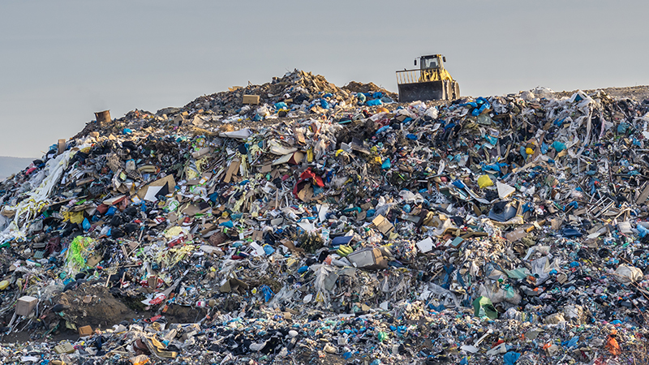

6. Why are stems of some plants like potato, onion, and ginger fleshy?

7. Can a dead stem also conduct water like a living stem?

8. Which type of separation is shown in the following figure?

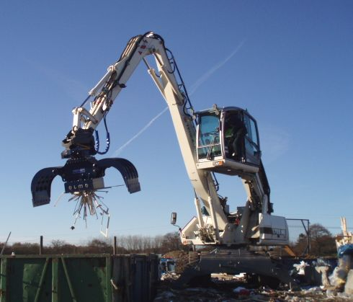

9. Identify the given separating mixture processes

**a. 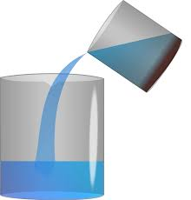 b. 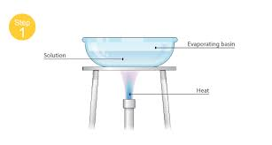 c.** 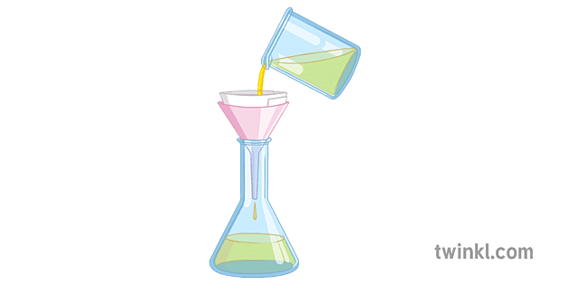

**III) Answer the following**

1. Threshing is followed by winnowing to separate husks from grains. How are the two Methods different?
2. Black pulses and small black stones have been mixed together by a student in science class. Will handpicking be an effective method of removing the stones from the pulses?
3. The handles of the tool like screwdrivers and pliers used by electricians or repair

Work usually has plastic or rubber covers on them. Can you explain why?

1. How does grouping objects help a librarian?
2. Which types of separations are given below? What is the common name for this separation? Write one example for each?
3. 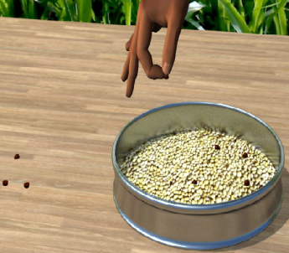 (b) 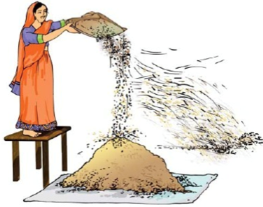(c)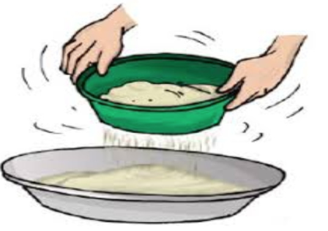

**xxxxxxxxxxxxxxxxxxxxxxxxxxxxxxxxxxxxxxxxxxxxxxxxxxxxxxxxxxxxxxxxxX**