 **AL KHOZAMA INTERNATIONAL SCHOOL,DAMMAM**

Affiliated to CBSE – New Delhi, No:5730019 **WORK SHEET - II**

**GRADE: I**

**EVALUATION-1/ FIRST TERM EXAM, 2019-20**

**SUBJECT: MATHEMATICS**

**Block 1-Nearby Numbers 0 to 10, Block 2-Making 5s and 10s, Block 4-Count 1 to 20,**

**Block 5-Numbers 11 to 20, Block 6-Introduction to comparing, Block 7-Numbers 20 to 49**

**____________________________________________________________________________**

1. **Circle the smaller object and underline the bigger object**.
2. 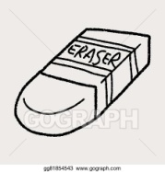

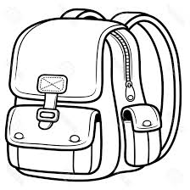 b)

1. **Write how many more or less.**

a)

🕭🕭🕭🕭🕭🕭_____________

🕭🕭**____________________**

1. 🖂🖂🖂🖂🖂🖂🖂________

🖂🖂🖂🖂🖂🖂🖂🖂🖂____

1. **Find the tens and ones in the picture.**

|  |
| --- |
|  |

a)

There are _________ tens and _________ ones.

b)

|  |
| --- |
|  |

There are _________ tens and _________ ones.

1. **I have 2 tens and 4 extras.What is the number?**

|  |
| --- |
|  |

1. **Change the picture to make 5 apples in total.**

