**AL KHOZAMA INTERNATIONAL SCHOOL,DAMMAM**

**Affiliated to CBSE – New Delhi, No:5730019**

**WORKSHEET - 1**

**GRADE: 4 – EVALUATION-1 (JUNE 2021-2022)**

**SUBJECT: Social Science**

**BLOCK-3&16:___________________________________________________________**

**I. Identify the following professions and fill the column**

**1** 234

|  |  |  |  |
| --- | --- | --- | --- |
| **Name of Profession** | **What they do** | **Tools they use** | **Training they need** |
|  |  |  |  |
|  |  |  |  |
|  |  |  |  |
|  |  |  |  |

**II. Match the following**

**a)Doctor -- -- - A. Drafting Board**

**b) Weaver- -- -- - B. Oven**

**c) Carpenter- --- - C. Voltmeter**

**d) Chef -- -- -- - D. Saw**

**e) Architect -- -- - E. Weaving Machine**

**f) Electrician -- -- - F. Stethoscope.**

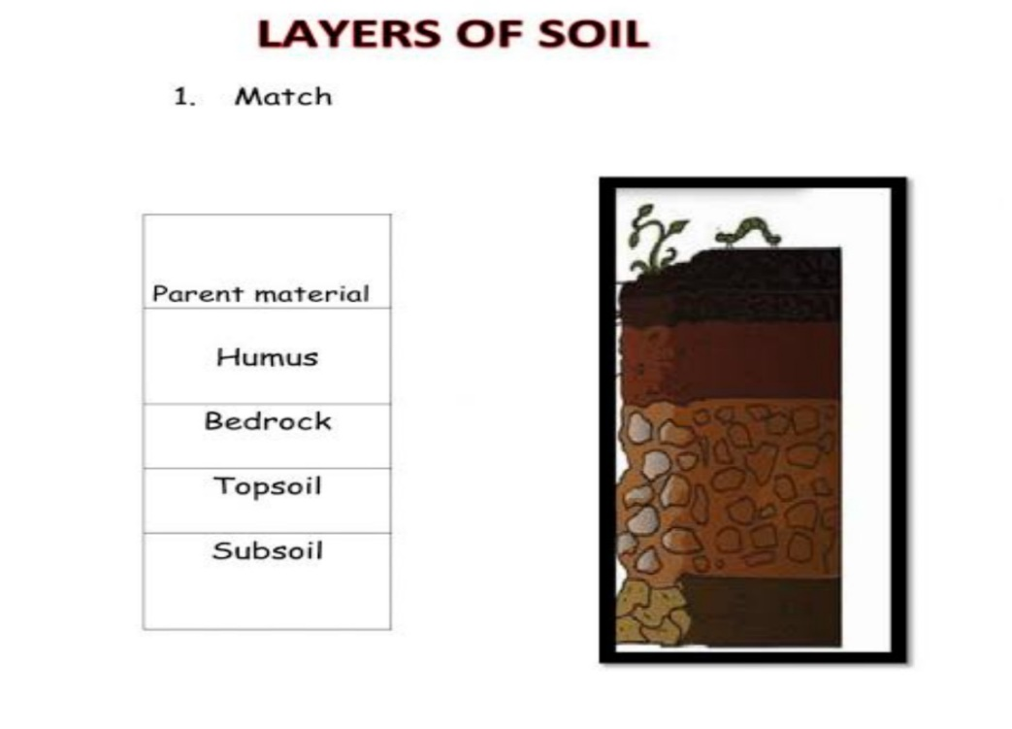

**IV. Answer the following questions in two to three sentences.**

a.Why do weavers face problems?

b. Why do we have different kinds of work?

c. Write the differences between the work of a doctor, a teacher and plumber. write one similarity between them.

d.How is alluvial soil different from desert soil?

e. Write the steps to conserve soil?