AL KHOZAMA INTERNATIONAL SCHOOL, DAMMAM

Affiliated to CBSE – New Delhi.
Work sheet-1
FIRST TERM EXAM, 2019-20
Subject: Social Science
GRADE: VIII
- Choose the correct word from the brackets to fill in the blanks.
i. The European trading companies came by ____________ (Sea/Land)
ii. The Mughal ruler___________ (Akbar/ Aurangzeb) issued a Farman to the EEIC.
iii. The purpose of the Europeans in India was ____________( Exploration/ Trade)
- The pie chart shows the percentage of religious communities in a country. Read the pie chart and answer the questions.
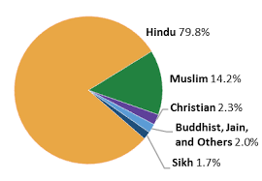
i. Based on the pie chart, list the religious communiteis whicha re in a minority.
________________________________________________________________________________________
ii. The government passed a law that students belonging to other religious communities
must learn about Buddhist religion in schools. Read the pie chart and write if you this is
fair ina secular state. Give reason for your answer.
________________________________________________________________________
________________________________________________________________________
________________________________________________________________________
- Why and where did presidency cities established by the English East India Company come up?
________________________________________________________________________________________________________________________________________________________________________________________________________________________

- Identify the policy or doctrine that applies to the lines below and name one territory or state annexed by its expense.
i. The British offered a pension to the rulers to leave the fort and give up the kingdom.
_________________________________
ii. The policy specified, allowed the British to capture the kingdom in the absence of an
heir : _____________________________
- Why did the duel government come under severe criticism? ________________________________________________________________________________________________________________________________________________________________________________________________________________________
- Identify the following methods of soil conservation and how does it practice it?
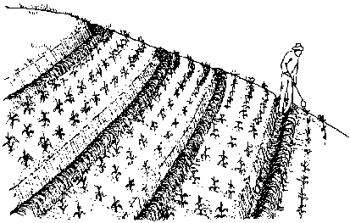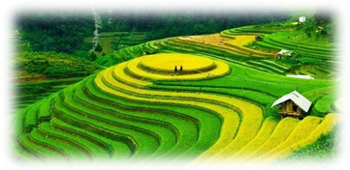
A B
A:______________________________________________________________________________________________________________________________________________
B:______________________________________________________________________________________________________________________________________________
- Which layer of the soil profile is the most useful to human beings and other forms of life?
________________________________________________________________________________________________________________________________________________________________________________________________________________________
- Name any two threats arising from soil and land degradation.
________________________________________________________________________
- Write one sentence each to explain how the following contribute soil fertility.
Micro organism
Organic matter

- Explain how overgrazing can lead to soil and land degradation.
________________________________________________________________________________________________________________________________________________________________________________________________________________________
- It takes 500 years for an inch of top soil to be formed, would the soil be fertile at the end of 250 years? Give one reason to support your answer.
_______________________________________________________________________
- Why secularism important in a democracy? How can we make sure that religion is separate from the control of state?
________________________________________________________________________________________________________________________________________________
- What were the main features of the subsidiary alliance? ________________________________________________________________________________________________________________________________________________________________________________________________________________________
- Highlights the differences in the way Rani Lakshmi Bai and the Nawab of Awadh reacted to the British demand for their kingdom?
________________________________________________________________________________________________________________________________________________________________________________________________________________________________________________________________________________________________
- How did the battle of Plassey become famous as the first major victory for the British in Bengal?
________________________________________________________________________________________________________________________________________________________________________________________________________________________
- Why do you think it was important for the British to defeat the French?
________________________________________________________________________________________________________________________________________________
- Give an example of how some people might dominate other members of the same religious community?
________________________________________________________________________________________________________________________________________________________________________________________________________________________

- What is the meaning of the term “land use”? Explain the factors that determine land
Use. ________________________________________________________________________
________________________________________________________________________________________________________________________________________________
- Write any two features of a secular country.
- Mark the following types of soil on the outline map of the world.
- Desert soil b)Grass land soil c) Mountain soil
d) Forest soil e) Tropical red soil
