AL KHOZAMA INTERNATIONAL SCHOOL, DAMMAM, K.S.A

Affiliated to CBSE – New Delhi, Affiliation No. 57300019
WORKSHEET .2
GRADE: IV –EVALUATION I
SUBJECT:Urdu (TL)

س1۔
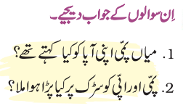
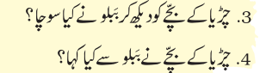
س2۔
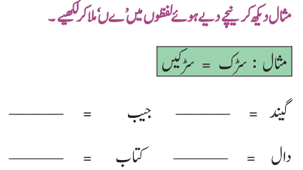
س3۔
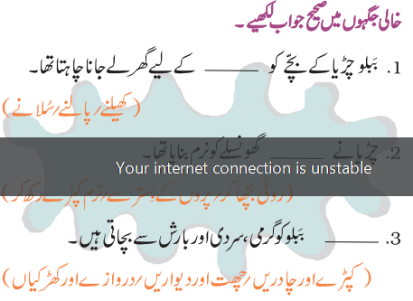
س4۔
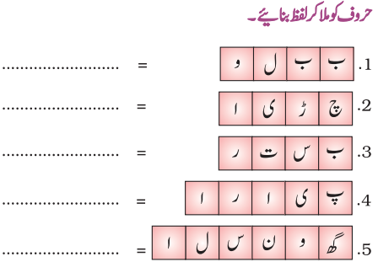

س5۔
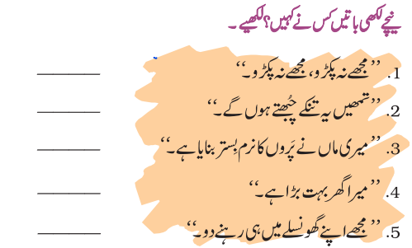
س6۔
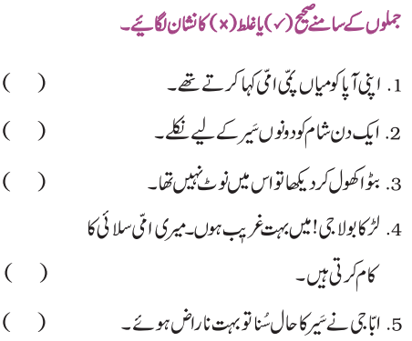

س7۔
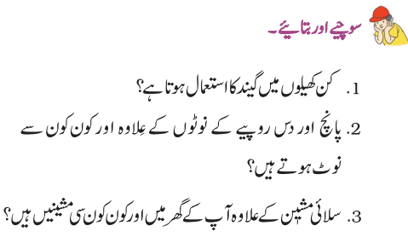
س8۔


