**AL KHOZAMA INTERNATIONAL SCHOOL,DAMMAM**

Affiliated to CBSE – New Delhi, No:5730019

**WORKSHEET - 1**

**GRADE: 7 – FIRST TERM EXAMINATION SUBJECT: Social Science**

**Block-1, 13 & 21**

**Choose the correct answer.**

1. Cartographer is a person who makes:

(a) Cartoons (b) Caricatures

(c) Maps (d) None of these

2. In which period did the number and variety of textual records increase dramatically?

(a) 600 to 700 (b) 700 to 800

(c) 800 to 1000 (d) 700 to 1750

3. What does democracy mean?

(a) Equal right to vote (b) Unequal right to vote

(c) Discrimination (d) All of these

4. The Indian constitution recognizes

(a) all people are equal (b) all people are not equal

(c) all people are economically sound (d) none of these

5. What is the central feature of Democracy?

(a) Inequality (b) Discrimination

(c) Equality (d) restrictions

6. Which of the following country is a leading producer of rice?

(a) China (b) Pakistan

(c) Malaysia (d) Egypt

7. Where were the manuscripts placed?

(a) At home (b) In libraries

(c) In archives (d) both (b) and (c)

**Matchthefollowing**

1. Land (a) lithosphere

2. Animals, plants (b) atmosphere

3. Mountain, plateau and plains (c) abiotic

4. Gases, water vapor, dust (d) biotic

**Answerthefollowingquestion**

|  |
| --- |
| Biography, auto biography, coins, temples, forts, account registers, travelogues, letters, statues, paintings, maps. |

|  |  |  |
| --- | --- | --- |
| …………….. sources | ……………….. sources | ……………… sources |
|  |  |  |

1. From the list below classify the different sources under three main headings.

2. **In India, People elect representatives to the government. There are elections every 5 years. Decisions are taken collectively by elected representatives. People are free to criticize the government and they enjoy many fundamental rights.**

* Find the democratic features from the passage and write them down. How is democratic government different from authoritarian government?

………………………………………………………………………………………………………………………………………………………………………………………………………………………………………………………………………………………………………………………………………………………………………………………………………………………………………………………………………………………………………………………………………………………………………………………………………………………………………………………………………………………………………………………………………………………………………………………………………………………………….

3. The image represents early man before he learned to make tools, and much before the discovery of fire and the invention of the wheel.

Explain the interaction of man with the different environments for his daily needs at this stage of evolution.

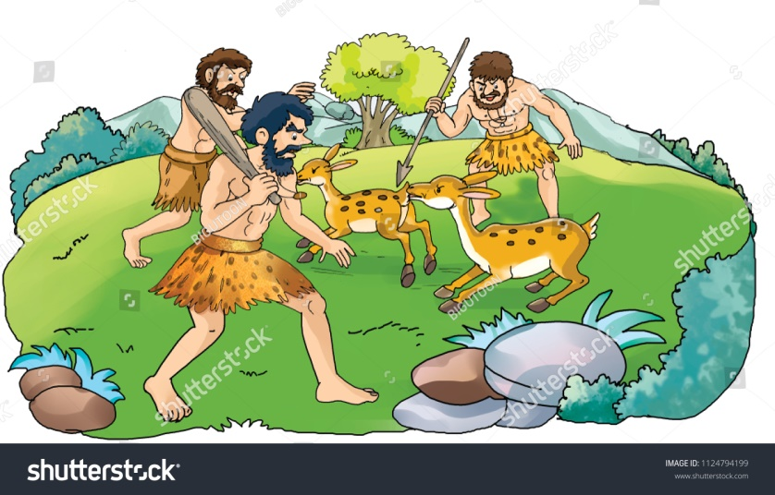

……………………………………………………………………………………………………………………………………………………………………………………………………………………………………………………………………………………………………………………………………………………………………………………………………………………………………………………………………………………………………………………………………………………………………………………………

4. Should history be divided in to periods? Why or why not?

……………………………………………………………………………………………………………..................................................................................................................................................................................................................................................................................................................................

5. Why do you think most countries in the world have democratic form of government? Support your answer with reason.

………………………………………………………………………………………………………………………………………………………………………………………………………………………………………………………………………………………………………………………………………………………………………………………………………………………………………………………………………….

6. Explain how the desert ecosystem will be affected if snakes go extinct.

………………………………………………………………………………………………………………………………………………………………………………………………………………………………………………………………………………………………………………………………………………………

7. Why is the medieval period often known as dark ages and compared unfavorably with the modern period?

…………………………………………………………………………………………………………………………………………………………………………………………………………………………………………………………………………………………………………………………………………………………………………………………………………………………………………………………………………

8. Write any five disadvantages of democratic government.

………………………………………………………………………………………………………………………………………………………………………………………………………………………………………………………………………………………………………………………………………………………………………………………………………………………………………………………………………….

9. Look at the following ecosystem and answer the following questions.

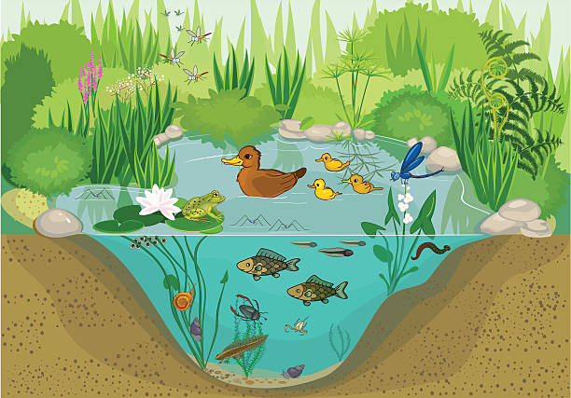

* Identify the ecosystem.

…………………………………………………..

* What are the two components of this ecosystem?

……………………………………………………………

* Draw a food chain from the above ecosystem.

…………………………………………………………………………………………………………

* How does human components different from Human made components? Explain with an example.

……………………………………………………………………………………………………………………………………………………………………………………………………………………………………………………………………………………………………………………………………..

* Why should we protect the entire ecosystem in the nature? Explain in detail.

……………………………………………………………………………………………………………………………………………………………………………………………………………………………………………………………………………………………………………………………………………………………………………………………………………………………………………………………………………………………………………………………………………………………….

10. Arrange the events on the given timeline

* Direct democracy in Greece,7th century BCE
* Countries adopt democratic governments after 1945
* Women granted the rights to vote in England,1928
* First written constitution of democratic country, 1789
* Bill of rights passed by the parliament,1689

* What according you was the most important event in the history of democracy and why?

………………………………………………………………………………………………………………………………………………………………………………………………………………………………………………………………………………………………..

************************