**Al KHOZAMA INTERNATIONAL SCHOOL, DAMMAM,K.S.A**



Affiliated to CBSE – New Delhi **WORK SHEET-2**

**GRADE: III**

**EVALUATION-1, 2019-20**

**SUBJECT: SCIENCE**

**Block 4: Features of birds**

**Block 5: Creepy crawly animals**

**Block 6: Food habits of animals**

**Block 7: Movement in animals.**

**__________________________________________________________________________**

**I.Fill in the blanks**

**1.** __________________ feathers are colourful feathers, which cover the body of a bird.

2. ______________________ has a sharp and curved beak.

3. All bird has 2 feet and _____________ toes.

4. Grass hopper eats _____________ of plants.

5. ___________________ can replace their lost body parts.

6. Zebra has _______________ and _________________ teeth.

7. ______________________ shows who eats whom.

8. The animals that eat only animals are called _______________

9. Birds have ___________________ bones.

10. Panda has strong ____________ that help them in climbing trees.

**II. Identify the picture and comment on it.**

**1.** 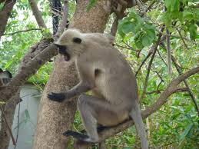

2.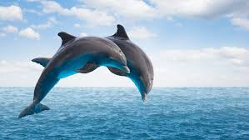

**3.**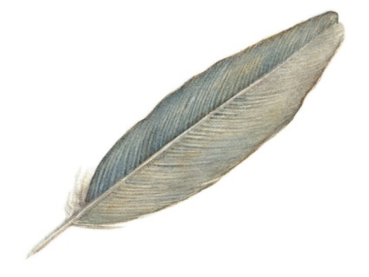

4.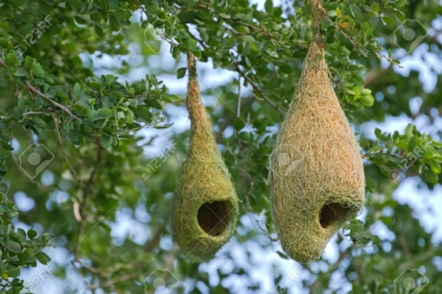

III. STATE TRUE OR FALSE.IF FALSE CORRECT IT

1. Squirrels swim in water to get food

____________________________________________________________________________________________________________________________________________

1. Frogs use their webbed feet to swim

____________________________________________________________________________________________________________________________________________

1. Sharks lose their teeth every 10 years

____________________________________________________________________________________________________________________________________________

1. Herbivores have sharp and pointed teeth.

____________________________________________________________________________________________________________________________________________

1. Antennae are known as feelers.

____________________________________________________________________________________________________________________________________________

1. Weaver’s bird uses its beak to stitch leaves to build the nest.

_____________________________________________________________________________________________________________________________________________

**IV. CIRCLE THE ODD ONE OUT AND GIVE REASON**

1. Cat, Dog, Elephant.

____________________________________________________________________________________________________________________________________________

1. Beak, Feet, Hollow bone

____________________________________________________________________________________________________________________________________________

1. Cricket, grasshopper, Earthworm

____________________________________________________________________________________________________________________________________________

**V.ANSWER THE FOLLOWING IN ONE SENTENCE.**

1.What kind of feet do duck have?

2.Name 2 hopping animals.

3.Why do you think butterflies sit on flowers?

4. Mention the role of hollow bones

5. What kind of teeth do tiger have?

______________________________________________________________________________________________________________________________________

VI. ANSWER THE FOLLOWING IN 2 -3 SENTENCES.

1. Why do different birds have different kinds of nest?

______________________________________________________________________

2. Why do ducks and kingfishers have different shaped beaks, even though both of them eat fish?

_____________________________________________________________________________________________________________________________________________________________________________________________________________________________________________________________________________________________________________________________________________________________

3. Make a food chain with the following.

Grasshopper, frog, grass, snake

|  |
| --- |
|  |

1. You invited an ant, a butterfly, and a mosquito at home. Write the food you would give them to eat on the plates below.

5. There are some animals that do not have teeth .How do they eat their food?

____________________________________________________________________________________________________________________________________________________________________________________________________________________________________________________________________________________________________________________________________________________________

6. Why does pigeon move from one place to another?

____________________________________________________________________________________________________________________________________________________________________________________________________________________________________________________________________________

7. Why do omnivores have both pointed and flat teeth?

_________________________________________________________________________________________________________________________________________________________________________________________________________

8. Describe the beaks of the following birds and mention its food habits.

