
AL KHOZAMA INTERNATIONAL SCHOOL, DAMMAM
Affiliated to CBSE – New Delhi
Subject: Social Science

Class 5 WORKSHEET -1
--------------------------------------------------------------------------------------------------------
- Choose the correct answer
- Big cities usually have small flats as houses. Therefore, we see more ____________________ families living in big cities.
(A. Nuclear B. Joint C. Big)
- The British rulers forced the Indian farmers to grow indigo instead of food crops. This led to a ____________________ as many people died of starvation.
- Drought B. famine C.flood)
- ____________________ occur when the rivers overflow their banks. (A Floods B. Hurricanes C. Cyclones)
- Ajanta and Ellora caves located in _______________.
(A Maharashtra B. Karnataka C. Tamilnadu .
5. Who was the founder of INC
(A SN Banerjee B. Ghandhiji C. Alan Octavian Hume

- Fill in the blanks
- Movement of people or animals from one place to another is called __________________
- Which country has the largest number of UNESCO heritage site in the world .___________________
- An Indian soldier serving under the British is called___________.
- Which is the highest judiciary in India ?
- A person selected for contesting election is called __________.

- Identify the picture
1.
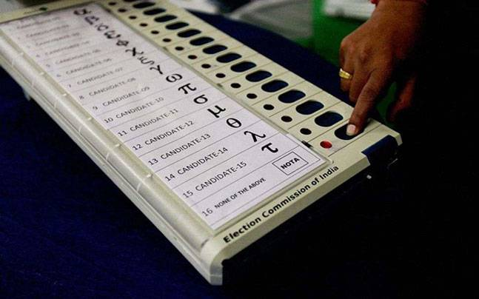
2.
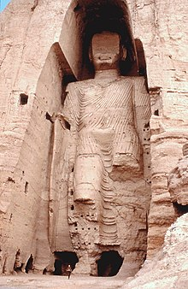
- Answer the following questions.
1. Compare the two pictures. How are they different? What do they tell you about families?



2.Some people want to break down a building in your area which is a few hundred years old, to build a hotel .List 2 reason why this is a good idea and 2 reason why it is a bad idea .

3. Look at the picture and answer the questions.

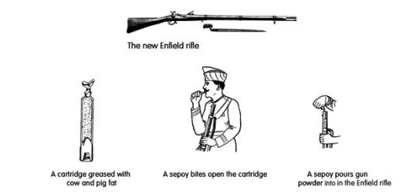

A.Why did the sepoys refuse to use the Enfield rifles?
B. Which revolt started because of this?
C. Name the Indian sepoy who started this revolt at Barrackpore.
4. Why did our freedom fighters have to use different methods to fight against British?
5. What steps can the government take to reduce the number of road accidents and robberies? Explain with examples.
6.
Last week, Priya and her friends visited the Taj Mahal. It was built more than300 years ago by the Mughal emperor Shah Jahan. About 20,000 people worked for almost 20 years to build this beautiful monument with white marble and precious stones.Priya was very sad to see that many people had written their names on its
walls.

A. Why do you think it is wrong to write on the walls of a historical monument? Give 1 reason.
B. Why do you think it is important to save the Taj Mahal? Give 1 reason.
C. Write 2 ways in which Priya can encourage people to take care of historical monuments
7. make a Venn diagram showing similarities and differences between the extremists and the moderate of the INC

