**AL KHOZAMA INTERNATIONAL SCHOOL, DAMMAM**



**Affiliated to CBSE – New Delhi**

**EVALUATION – 2, (2018 – 2019)**

**Subject: Mathematics**

**REVISION WORKSHEET – 1 (Block-9)**

**Name: Class: II Sec: Date:**

1. **Write the features of the solid shapes.**

|  |  |
| --- | --- |
| **SOLID SHAPES** | **FEATURES** |
| **images.jpg** |  |
| **GRD3_LS03_IMG15.jpg** |  |
| **download cone.jpg** |  |
| **Dctkp.png** |  |

1. **Rani wants to make a cube.**

**How many straws and balls of dough will she need?**

**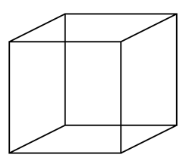**

1. **Number of straws =**
2. **Number of play dough balls =**
3. **Answers these questions:**
4. **Name two shapes that have no corners.**

**2. What flat shapes do you see in this solid shape?**

**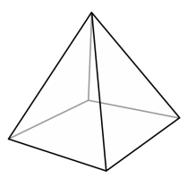**

**AL KHOZAMA INTERNATIONAL SCHOOL, DAMMAM**



**Affiliated to CBSE – New Delhi**

**EVALUATION – 2(2018 – 2019)**

**Subject: Mathematics**

**REVISION WORKSHEET – 2 (Block-9)**

**Name: Class: II Sec: Date:**

1. **Write the name of each shape. Also, match each solid shape with the flat shape that looks like it.**

**Solid shapes Flat Shapes**

**A.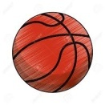**

**B.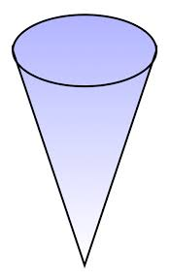**

**C.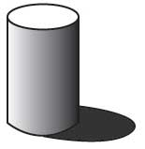**

**D.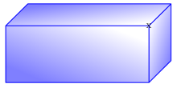**

1. **Name the shapes that have :**
2. **One circular face**
3. **No faces**
4. **Six rectangular faces**
5. **Eight corners**
6. **Name these shapes with examples.**

**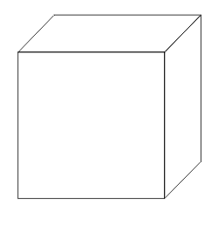**  **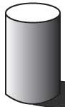** 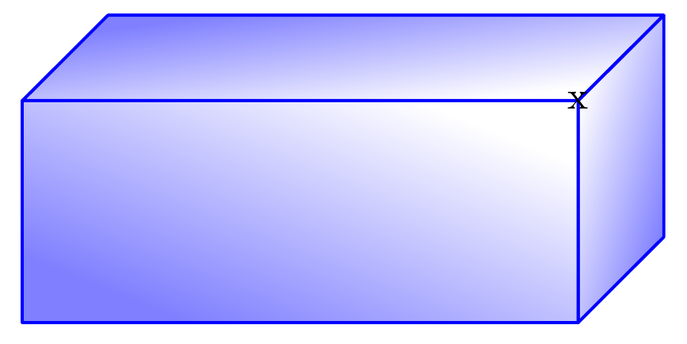

Name: \_\_\_\_\_\_\_\_ \_\_\_\_\_\_\_\_\_\_ \_\_\_\_\_\_\_\_\_\_\_\_ \_\_\_\_\_\_\_\_\_\_\_\_\_

Eg.: \_\_\_\_\_\_\_\_ \_\_\_\_\_\_\_\_\_\_ \_\_\_\_\_\_\_\_\_\_\_\_ \_\_\_\_\_\_\_\_\_\_\_\_\_

1. **Write one feature that is common between each pair of shapes.**
   1. Cube, Cuboid -
   2. Cone, Sphere -
   3. Cone, Cylinder -
   4. Cuboid, Cylinder -