
AL KHOZAMA INTERNATIONAL SCHOOL, DAMMAM,K.S.A

Affiliated to CBSE – New Delhi

WORK SHEET-2
GRADE: 6
SUBJECT: SOCIAL SCIENCE
__________________________________________________________________________

1. Fill in the blanks
- Rama and Sita are best friends. Rama speaks Hindi and loves to eat kheer, while Sita speaks Telugu and loves to eat payasam. This is an example of______________.
- Coins used by earlier people tell us about their lives. These old coins are an
Example of _________________ sources.
- Crude stone tools found in Bhimbetka belonged to the _________________ period.
- The word “India” comes from the name of _______________________________.
- The _________ cut each other at the right angles in the Harappan cities .
- The Halley’s comets can be seen from Earth every _______________years .
- Our solar system is located in a galaxy called_________________
- The earth rotates from ________________to ______________.
- The axis makes an angle of ________with the orbital plane .
- The axis of the Earth is not ____________but tilted.
II. . Answer the Following in 30 -60 words
- What is History ?
- How do we know that the Harappan people could weave cloths?
- Read the given text and answer the questions.
Meena visited a museum. She saw some coins, inscriptions, manuscripts and
sculptures of an ancient civilization that once existed in her country.
A. Fill the table with the types of sources she saw.
Literary Sources | Archaeological Sources
B. Suggest any 2 ways that can help Meena to learn more about her country
by studying its past.
- Why and how were the walls of the caves of Ajanta plastered?
- Prof Rajan has written books about different kings .Do you think he will provide complete information about past ? why/ why not ?
- If modern facilities such as electricity, telephones, cars torch and cooking gas are taken away from us, how do you think our lives will be affected? In what way do you think will it be similar to or different from the earliest people?
- What creates inequality between people?
- Draw a Venn diagram .Write 2 differences and 1 similarity between summer solstice
and winter solstice

III. . Answer the Following in 80 to 100 words.

- Look at the picture and answer the questions.

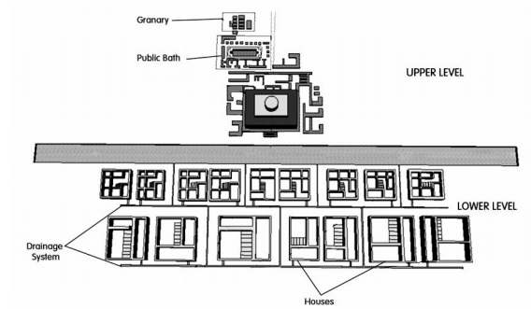

A. Name the 2 parts in which most of the Harappan cities were divided.
B. Write any 2 features of the each part.
First Part
Second Part

Write 1 material with which the Harappans made their houses.

- Answer the questions.
Early humans were hunter-gatherers. They used to move from place to place
for food and shelter. Changes occurred when people discovered fire,
domesticated animals, and learnt farming. It happened within the Stone Age,
and this separated the Old Stone Age or Palaeolithic Age from the New Stone
Age or Neolithic Age.

 | Palaeolithic Age | Neolithic Age
Activities
Places they lived in
Tools

- Differentiate the life of the people in the Palaeolithic and Neolithic Ages on
the basis of the given points

- What were the 2 things that changed the lives of the hunter-gatherers to
become settled farmers?

- Look at the image and answer the questions.

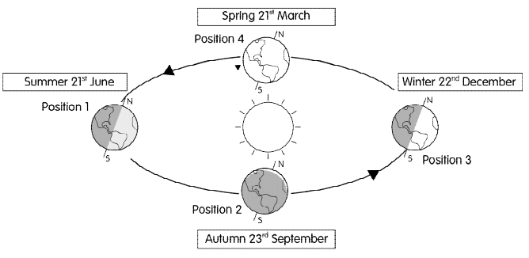
- Write 2 factors that cause the change in seasons.
- Why is the duration of the day and night equal on 21st March?

- Write any 4 features each

Earth (inner planet) | Saturn (outer planet)

- Write any 1 feature which is similar between Saturn and the other outer planets.
B. Write ANY 2 reasons that makes life possible on Earth.
C. Write ANY 1 way in which Mercury (inner planet) and Neptune (outer planet) are
Different.

- Read the text and answer the questions.
The Harappan civilisation was an urban civilisation. Some of the cities of the time were
Harappa, Mohenjodaro, and Lothal. The cities were divided into 2 parts — upper and
lower. The streets were built on a grid pattern that cut each other at 90 degree. The
people of the civilisation were involved in various crafts such as making pottery, beads,
and seals. Many seals of Harappan civilisation are found in places across the seas.

- Write ANY 2 features of Lothal.

- Write about ANY 2 sources which give us information about the crafts and trade of the
Harappan civilisation.

- Does any source about the Harappan civilisation tell us about its decline? Why?

D. Climate change was the major reason for the decline of the Harappan civilisation. you agree? Write 1 reason for your answer.

